**Assignment 01**

**Virtual Machine Setup**

**CS4061**

**Ethical Hacking Concepts and Practices**

**Submitted by:** Faizan Pervaz

**Roll number:** 20I-0565

**Date:** 10-02-2024

**Table of Contents**

• **Introduction** 3

• **Steps** 3

• **Summary** 3

• **References** 3

# **Introduction**

# For this assignment, our task entailed configuring virtual machines using VMware Workstation Pro within our host system. The objective was to establish these VMs in preparation for forthcoming assignments, facilitating our educational objectives and practical learning experiences.

# **Steps**

**Downloads:**  
Our assignment necessitated acquiring all essential materials either from the internet or the GCR. Attached below are screenshots detailing the specific steps and instructions outlining the required actions.

1. **Obtaining the VMware Setup:**



1. **Retrieving the Parrot OS ZIP Folder from GCR:**

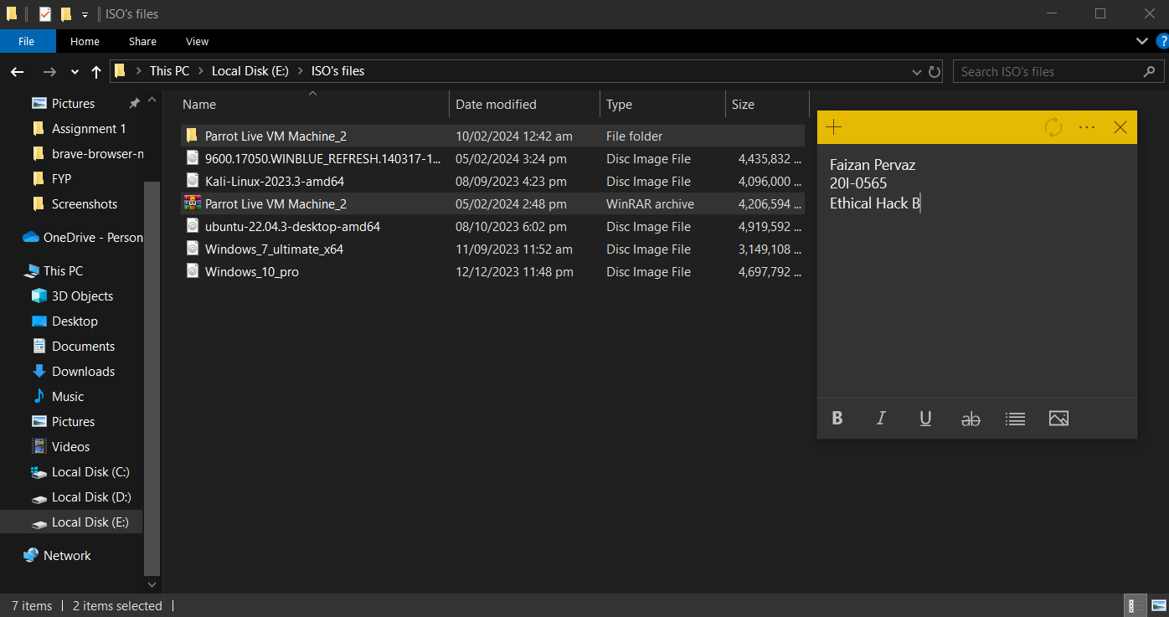

1. **Official site Windows 10 Download:**

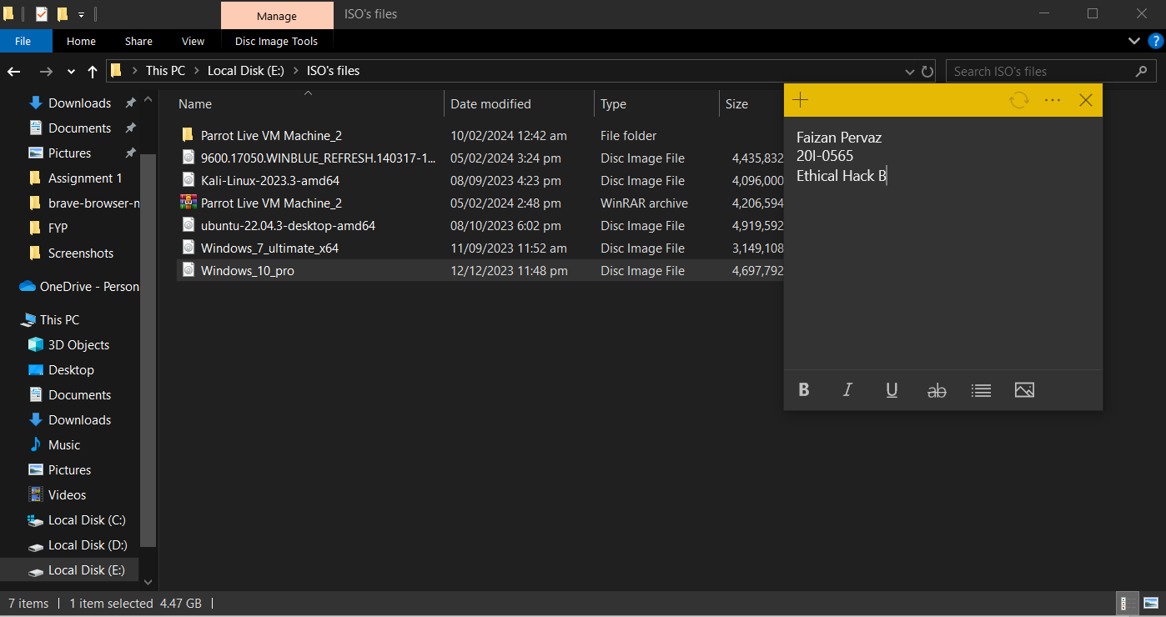

1. **Downloading Windows Server:**

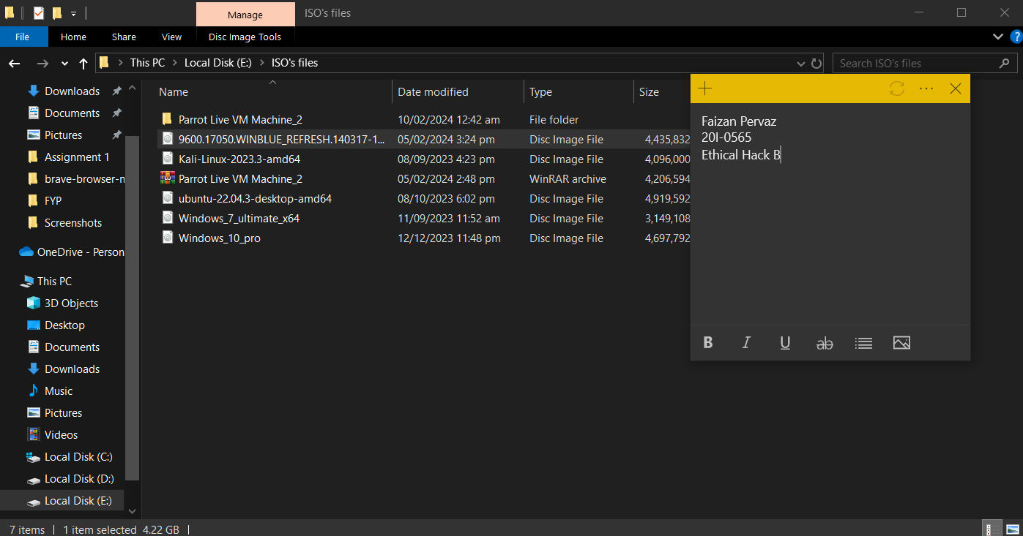

1. **Kali Linux VMware from official site:**

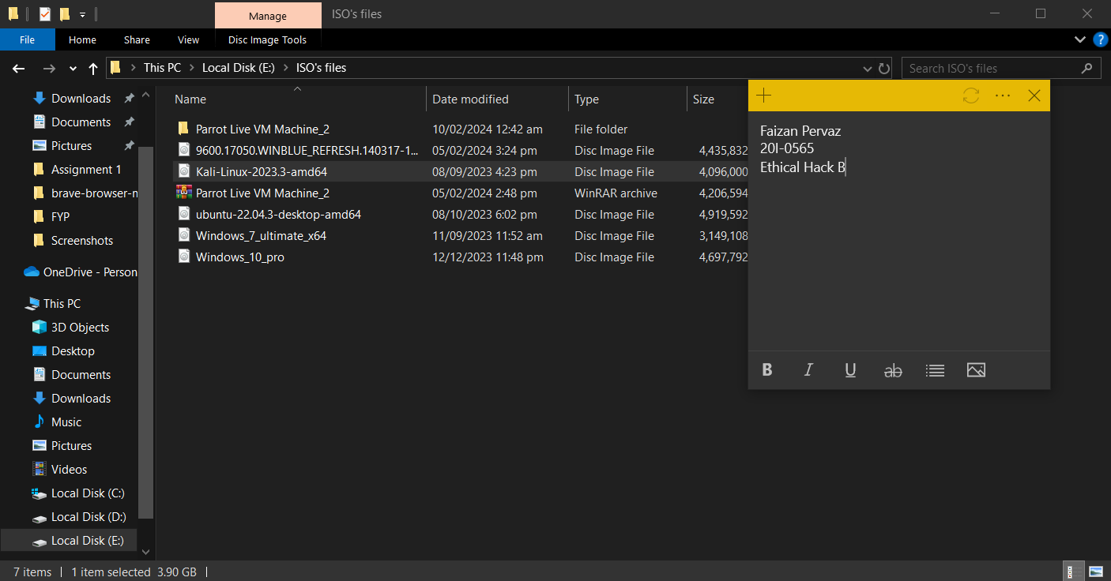

1. **Installing:**
2. **Vmware:**

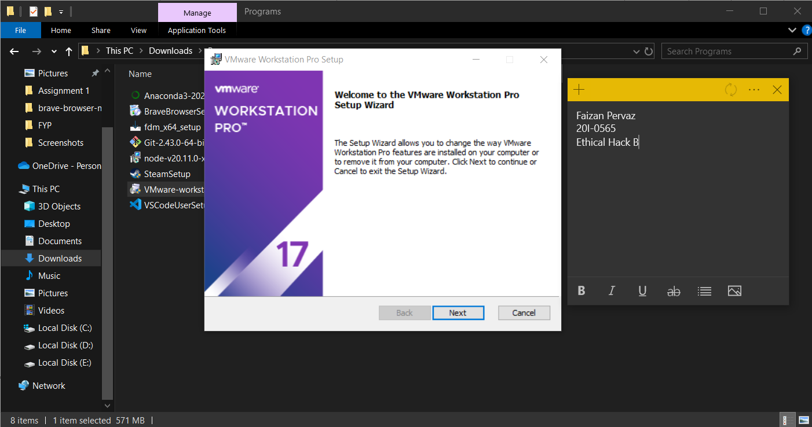

1. **Parrot OS (VMware zip folder):**

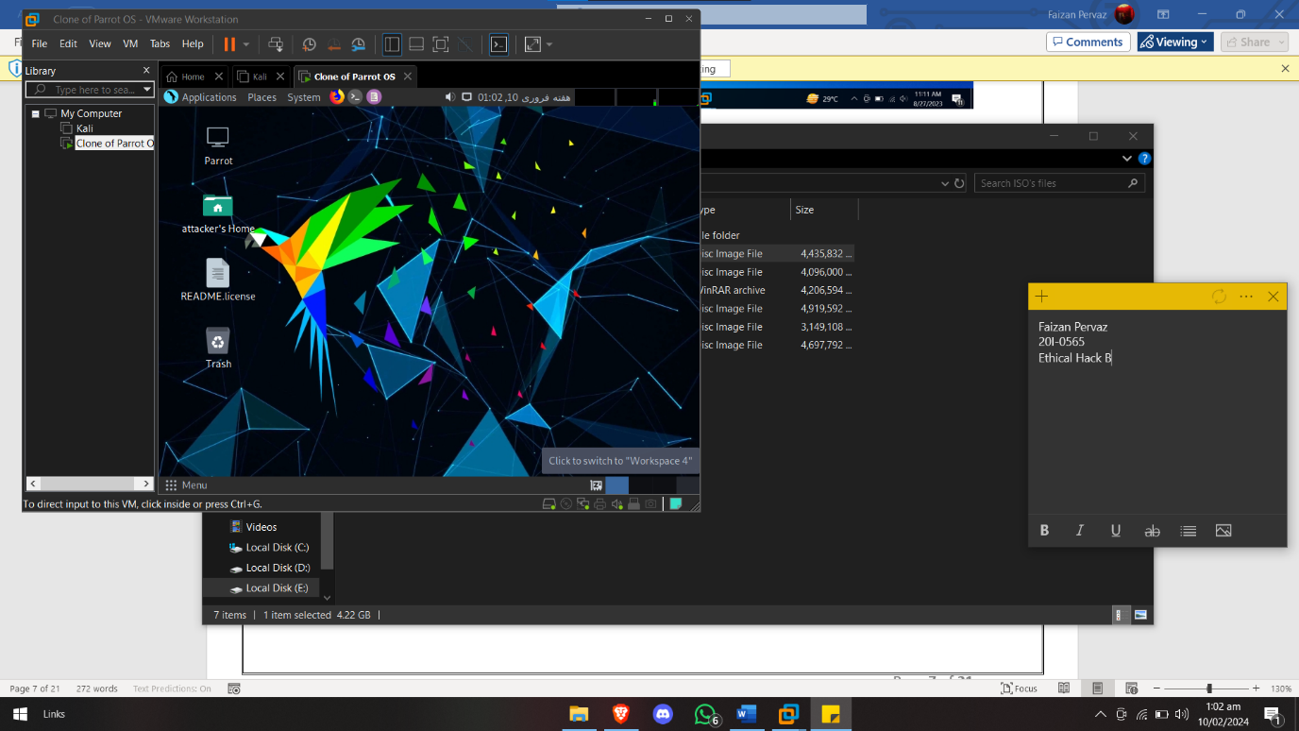

1. **Kali Linux:**

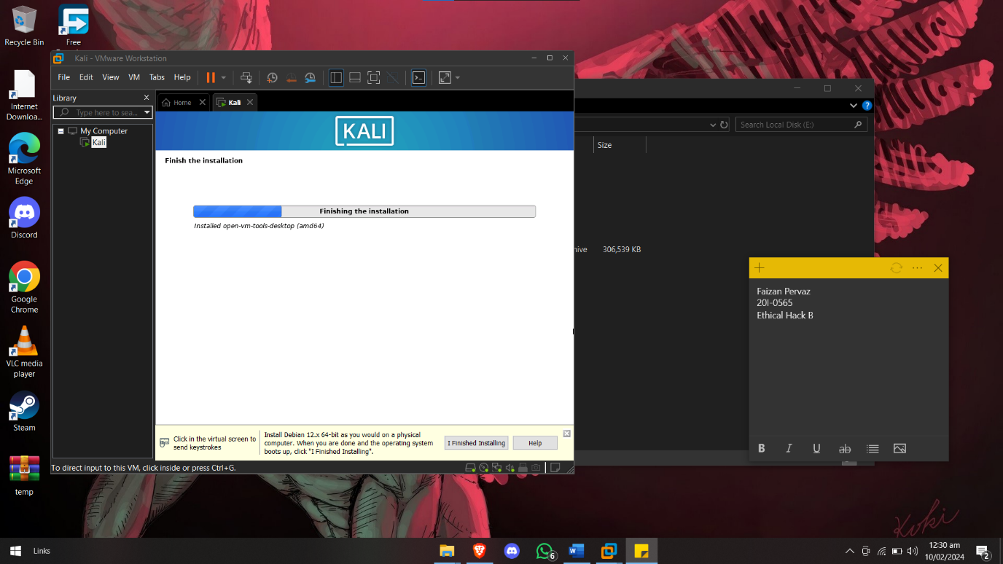

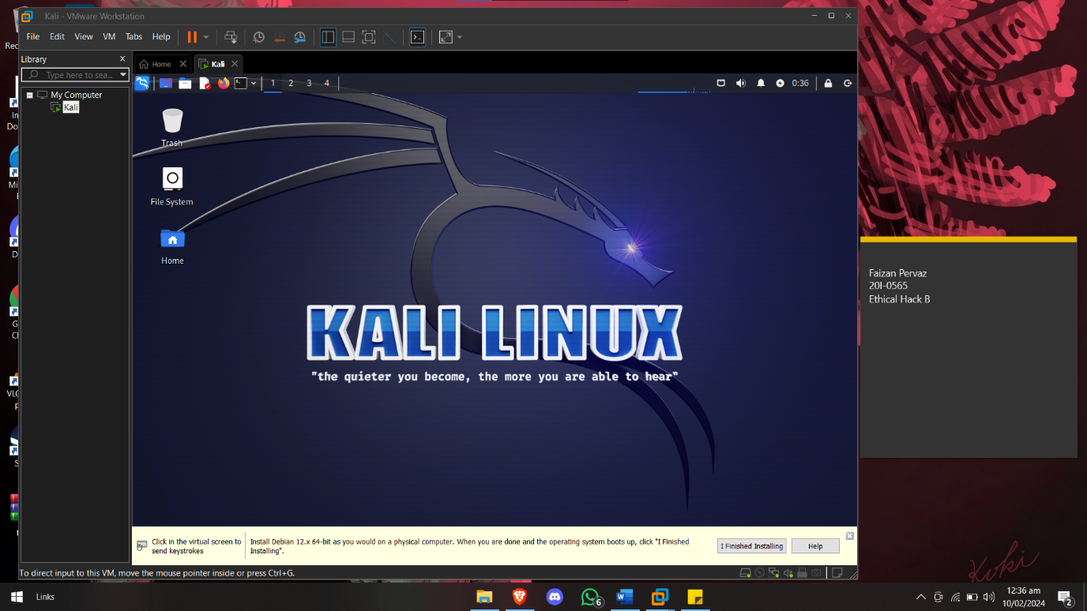

1. **Windows server:**

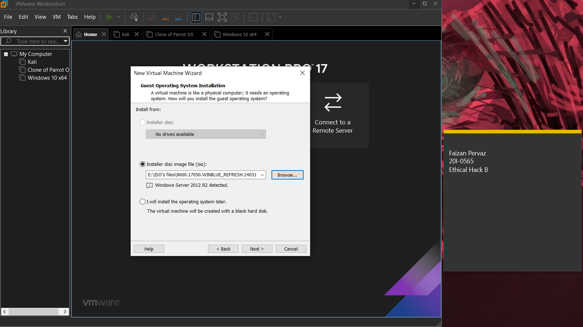

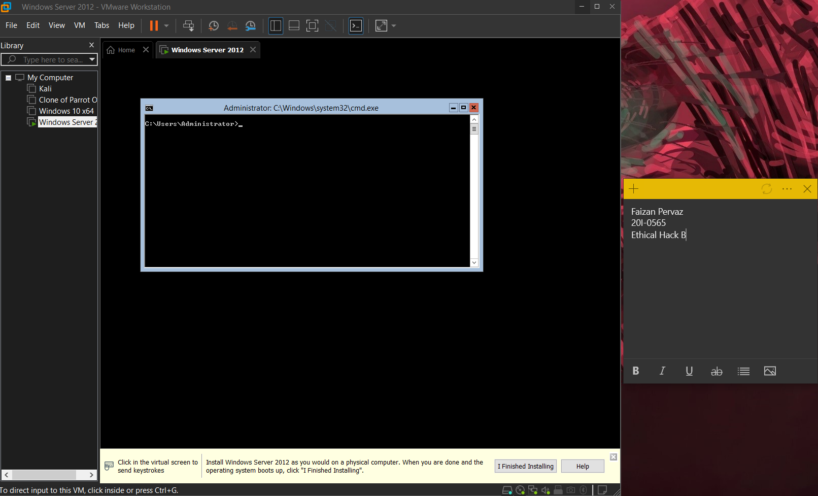

1. **Windows 10 pro (iso file):**

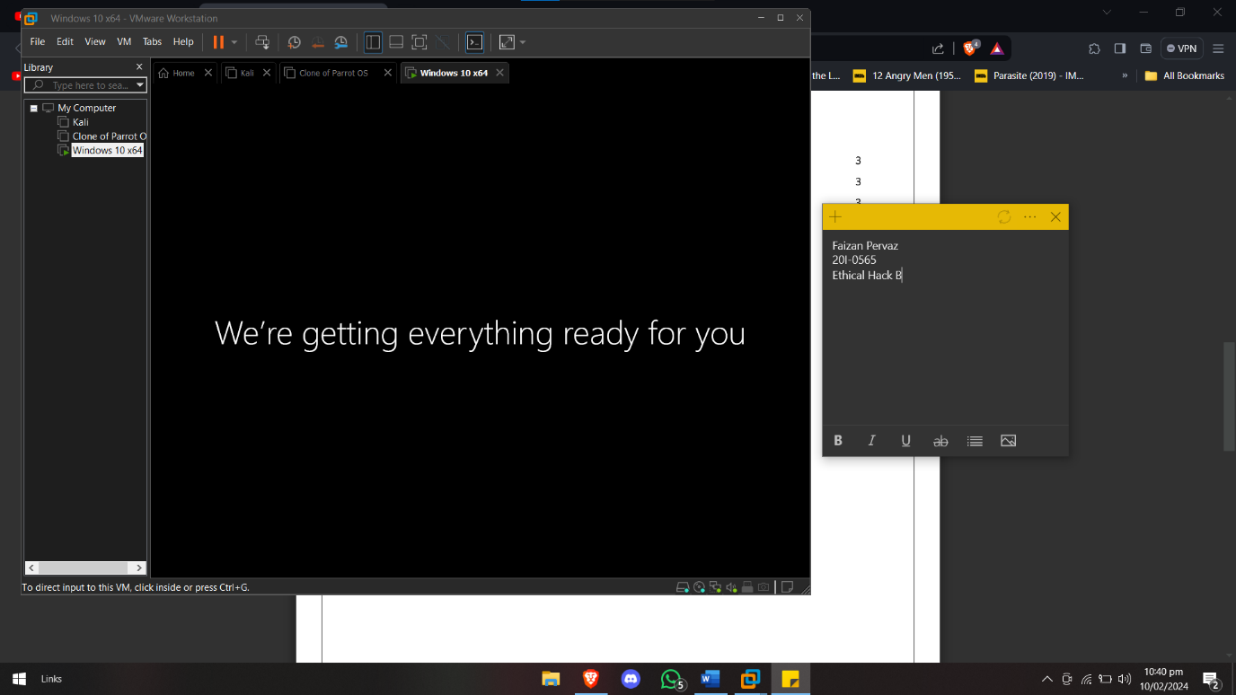

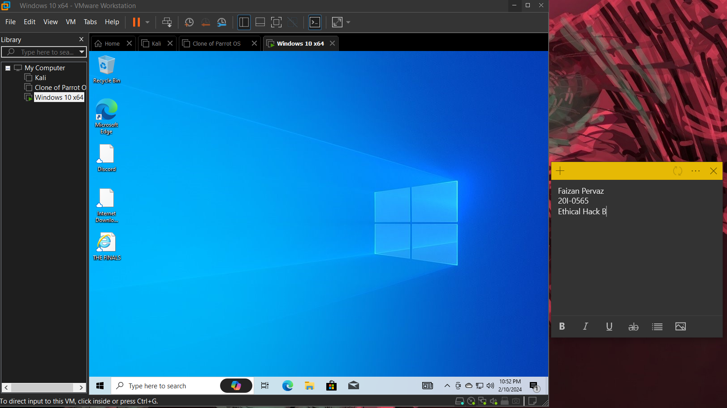

1. **VMware Tools:**
2. **Parrot OS:**

The VMware ZIP folder was utilized, incorporating preinstalled VMware Tools.Top of Form

1. **Kali Linux:**

The VMware ZIP folder was utilized, incorporating preinstalled VMware Tools.Top of Form

1. **Windows server:**

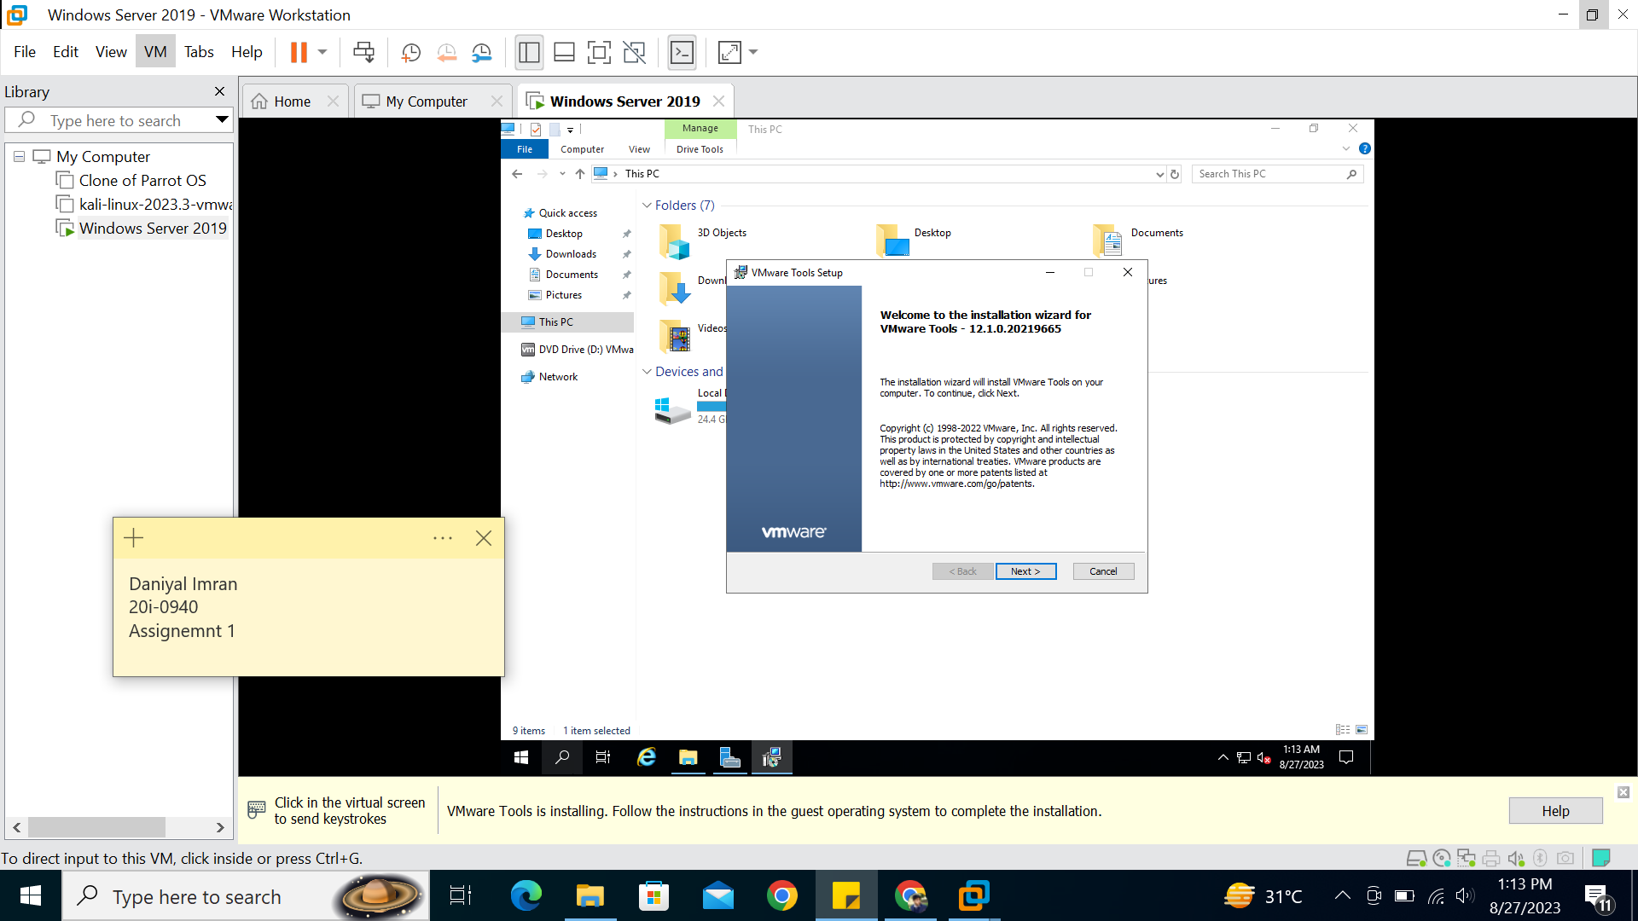

1. **Windows 10 pro:**

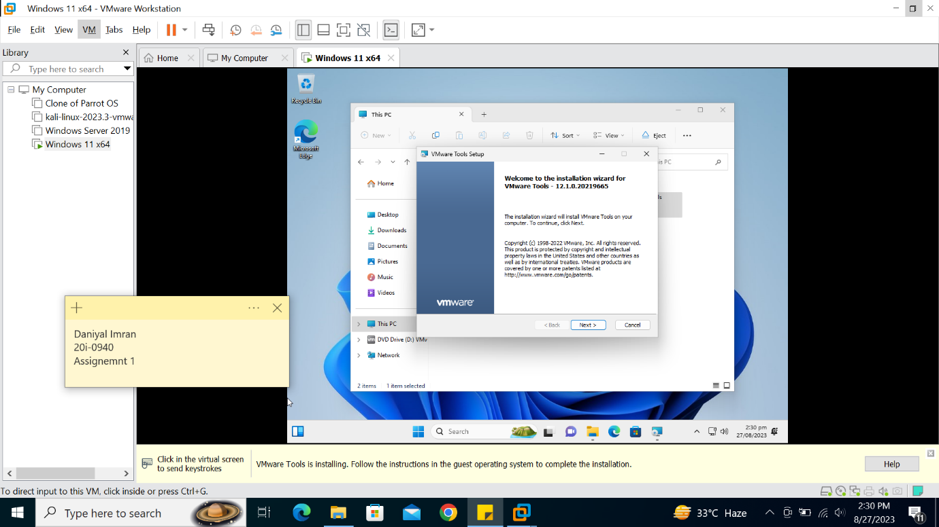

1. **Internet Connectivity:**
2. **Parrot OS:**

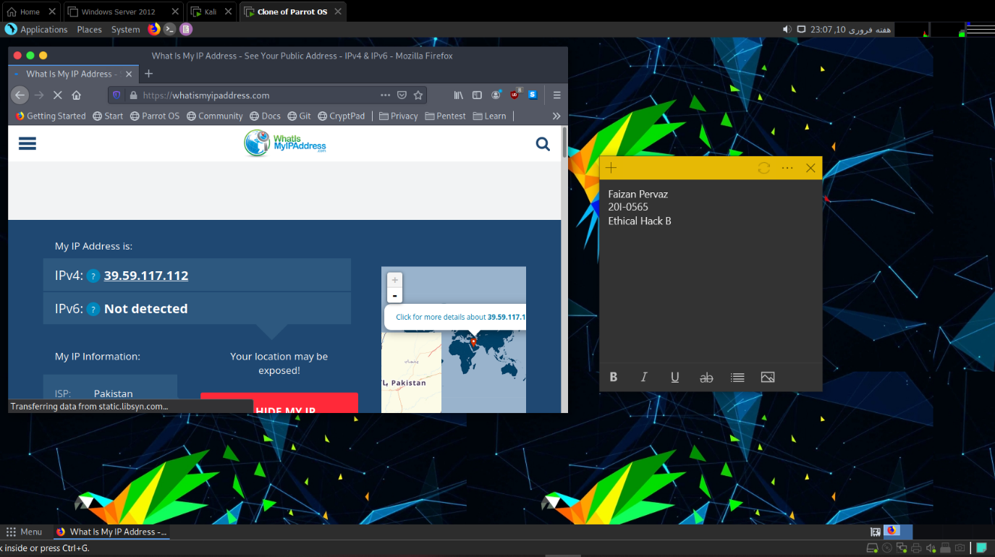

1. **Kali Linux:**

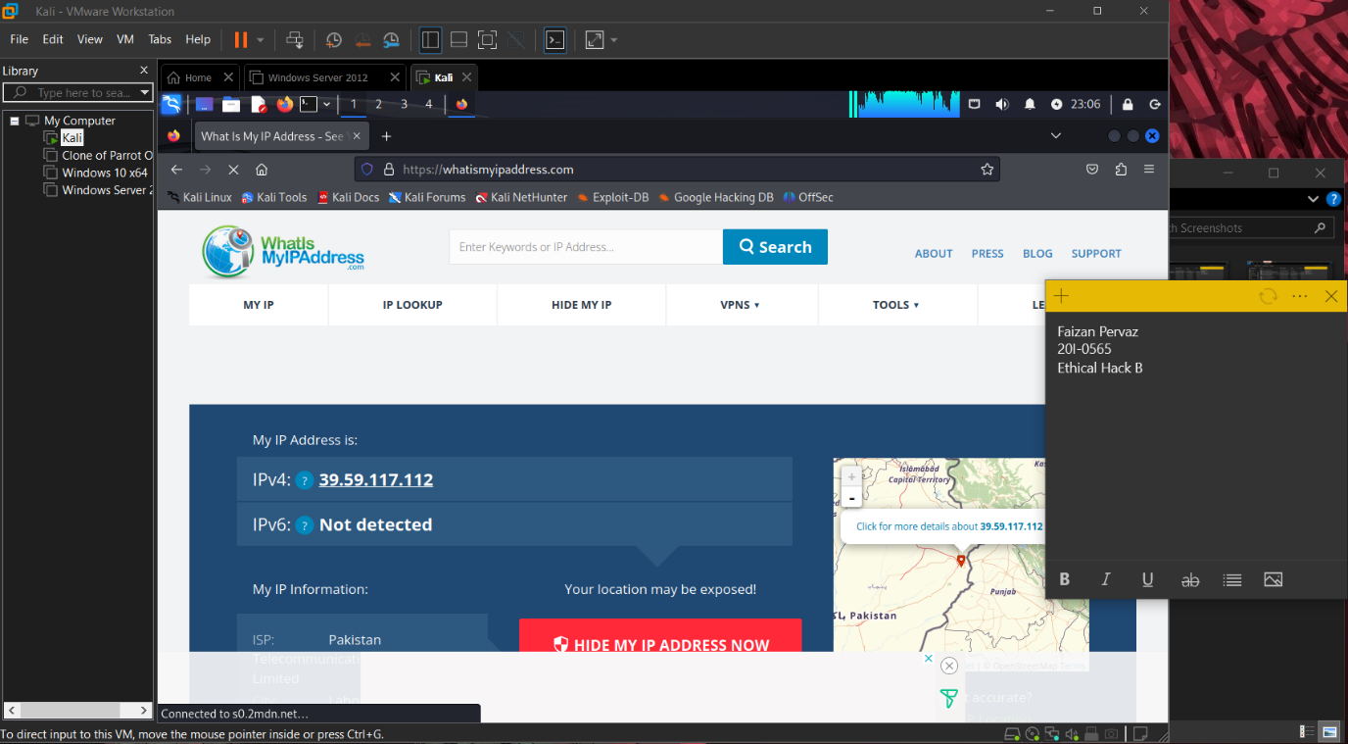

1. **Windows server:**

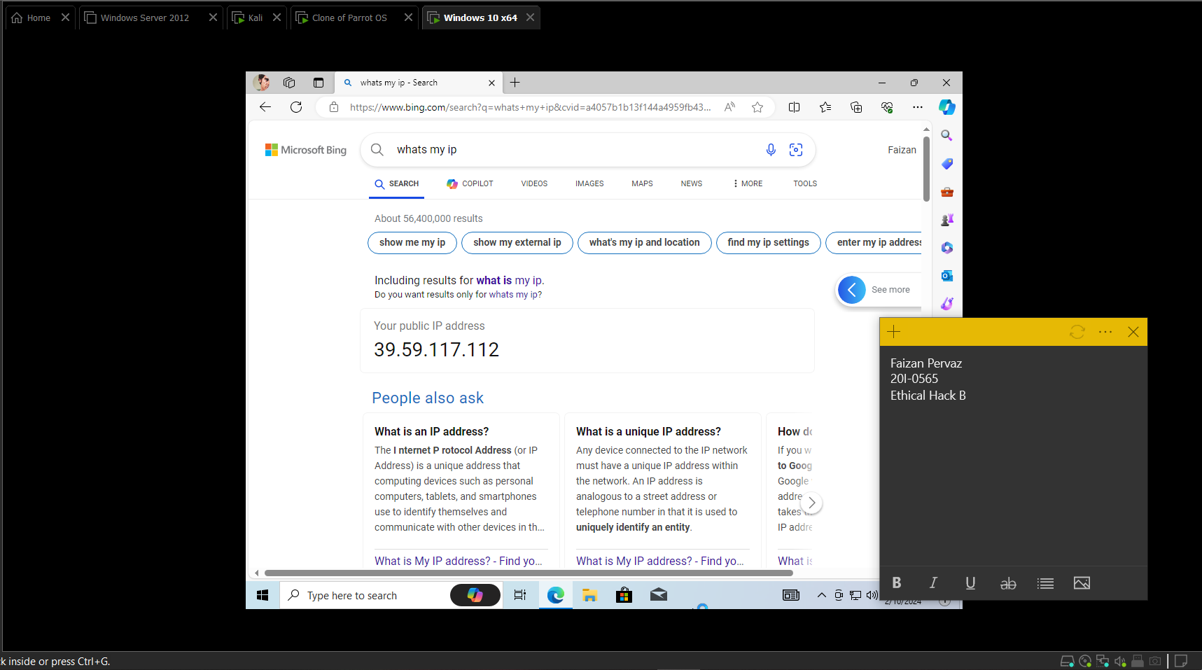

1. **Windows 10**



Shared folder

1. **Parrot os:**

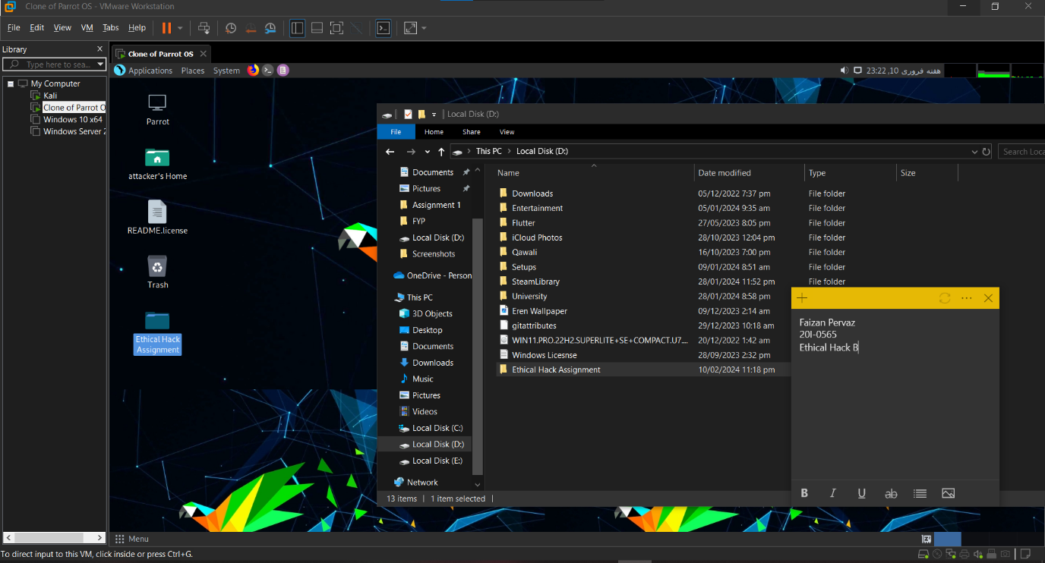

1. **Kali linux:**

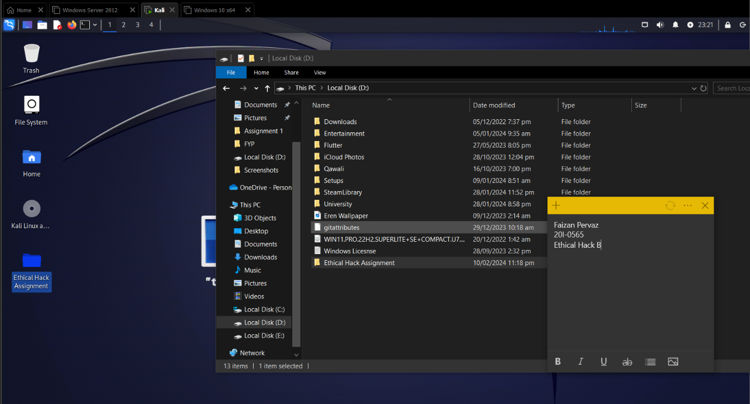

1. **Windows server:**

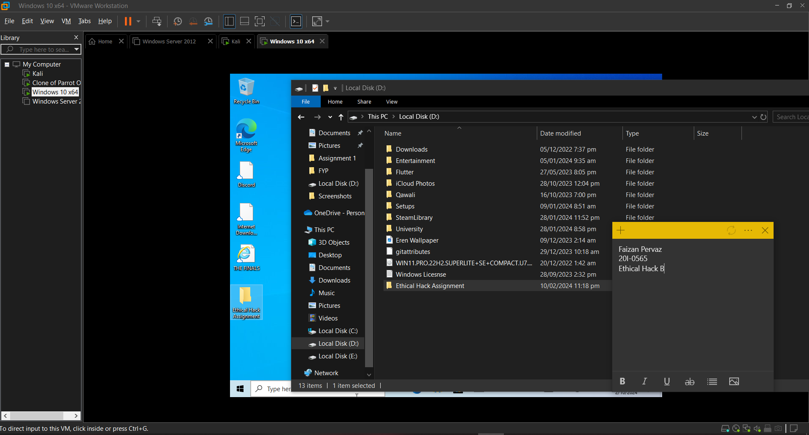

1. Windows 10:



**Drag and Drop:**

1. Windows 10:



1. Windows Server:

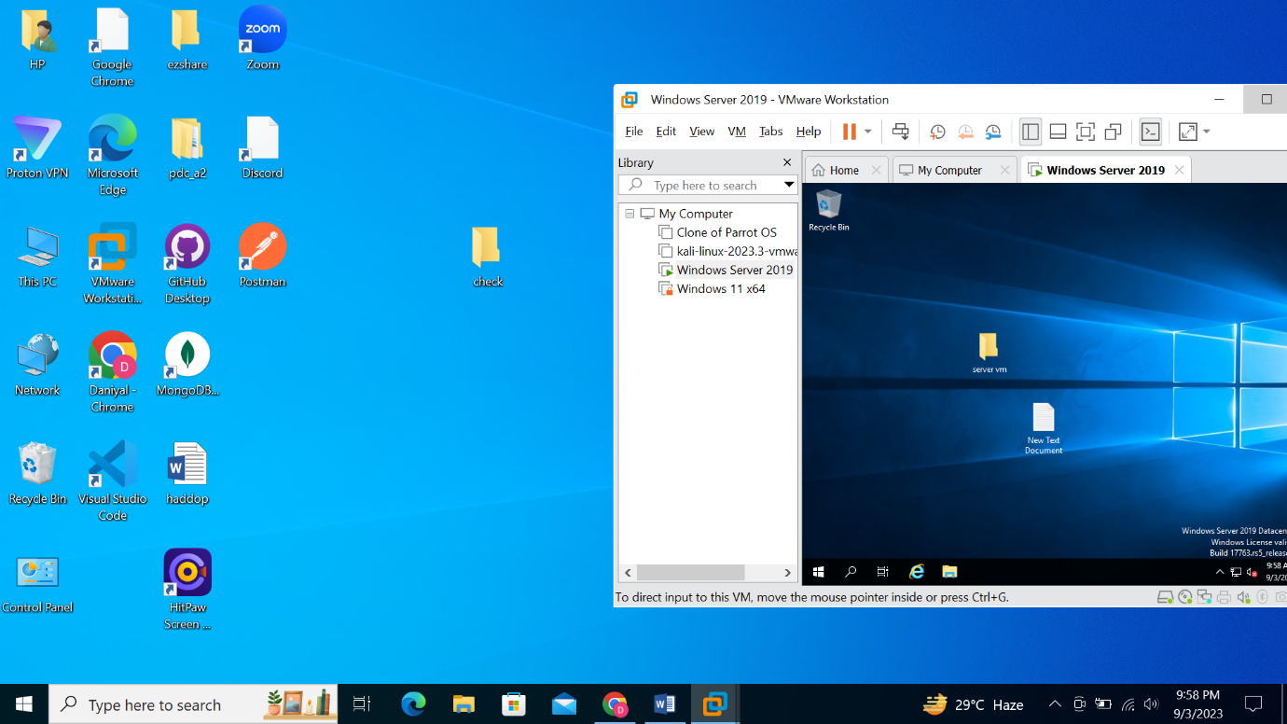

# **Summary**

As depicted above, the task involved downloading and installing four virtual machines essential for our future learning endeavors. The process of acquiring and installing these virtual machines was meticulously documented through a series of screenshots for reference and review.

**References**

1. <https://www.microsoft.com/en-us/evalcenter/download-windows-server-2012-r2>
2. <https://www.kali.org/get-kali/#kali-installer-images>
3. <https://www.microsoft.com/en-us/software-download/windows10>
4. Others From Ethical Hacking GCR including Parrot OS